Sonar Cloud init

1.Establish a new account at <https://sonarcloud.io/>

2.Analyze a new project

3.Link the remote repository

4.Pick the project

5.Pick GitHub Action

6.Add secret token to the git repository

7.Pick maven project

8.Add properties to the local repository and push changes

9.Set a workflow

Copy sonar cloud workflow template and paste it into git repository workflow

Update credentials like:

Branch, jdk, java version etc.

10.Commit the workflow

11.Pull the changes into local repository

12.Make sure the java version for the project is => 11

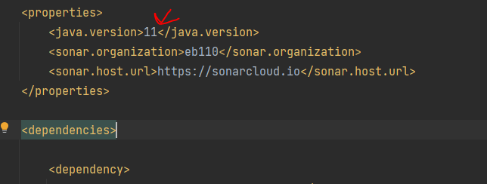

13.Push the project

14.Analyze the result

